**Habit Tracker Application Documentation**

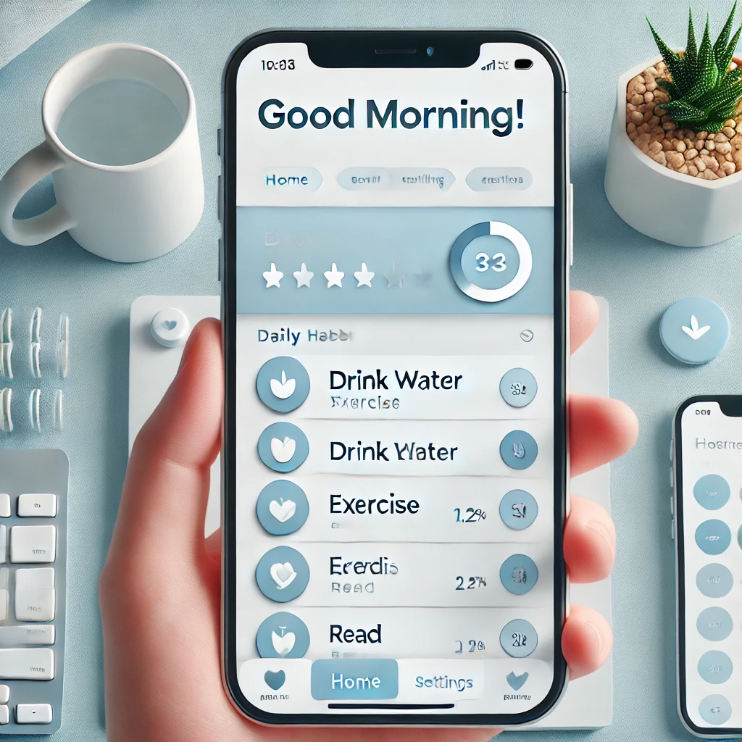

**1. Project Planning & Management**

**1.1 Project Proposal**

**1.1.1 Overview**



**The Habit Tracker Application is designed to help users build and maintain positive habits through goal setting, reminders, and progress tracking.**

The app provides an intuitive interface to create, monitor, and analyze daily habits, encouraging users to stay consistent and achieve their personal development goals. It aims to simplify habit formation by offering engaging and user-friendly experience, ensuring that users can seamlessly integrate positive routines into their daily lives. Through personalized habit tracking, insightful analytics, and motivational tools, this application empowers individuals to take control of their personal growth and maintain long-term success.

**1.1.2** Objectives

• Enable users to create and track daily habits efficiently.  
• Provide reminders and notifications for scheduled habits.  
• Offer data visualization and insights to analyze progress.  
• Ensure a seamless and engaging user experience.

**1.1.3** Scope

**The application will include:**

• Habit creation and customization.  
• Progress tracking and analytics.  
• Reminder notifications.  
• Streaks and rewards for consistency.  
• Data synchronization across devices (if applicable).

1.2 Project Plan

1.2.1 Timeline & Milestones

|  |  |  |
| --- | --- | --- |
| Phase | Milestone | Deadline |
| Planning & Research | Define project scope, conduct market research | [Date] |
| System Design | Finalize architecture, database design, and UI/UX mockups | 25/2/2025 |
| Development | Implement core features and functionalities | 20/4/2025 |
| Testing | Perform unit testing, integration testing, and user testing | 25/4/2025 |
| Deployment | Launch the app and monitor performance | 30/4/2025 |
| Maintenance & Updates | Address feedback and roll out improvements | Ongoing |

1.2.2 Resource allocation



**1.2.3 Technology Stack**

1.3 Task Assignment & Roles



1.4 Risk Assessment & Mitigation Plan

**2. Literature Review: Habit Tracking Applications**



1. **Introduction**



**Habits are fundamental behaviors that shape our daily lives, influencing productivity, health, and overall well-being. Establishing positive habits and eliminating detrimental ones are critical for personal development. However, the process of habit formation and maintenance can be challenging. In recent years, technology has played a pivotal role in assisting individuals to build and sustain habits through the development of habit tracking applications. These applications provide users with tools to set goals, receive reminders, and monitor progress, thereby facilitating behavior change and promoting consistency.**

**2. Existing Habit Tracker Applications**



**Several habit tracking applications have gained popularity due to their unique features and user-centric designs. An overview of some notable apps is presented below:**

* **Habitica**: This application gamifies habit tracking by transforming daily tasks into challenges within a role-playing game (RPG) framework. Users earn in-game rewards for completing tasks, making habit formation engagement and enjoyable.

[**LifeHack**](https://www.lifehack.org/668261/best-habit-tracking-apps?utm_source=chatgpt.com)

* **Coach.me**: Offering both habit tracking and professional coaching, Coach.me provides users with personalized support to achieve their goals. The app's community feature allows users to seek advice and motivation from others pursuing similar habits.

[**Develop Good Habits**](https://www.developgoodhabits.com/habit-tracking-apps/?utm_source=chatgpt.com)

* **Beeminder**: Beeminder employs a commitment contract approach, where users pledge monetary stakes to encourage adherence to their habits. If a user fails to meet their goals, they incur financial penalties, adding a tangible incentive to maintain consistency.

[**Integrately**](https://integrately.com/blog/best-habit-tracker-apps?utm_source=chatgpt.com)

* **Habitify**: This app emphasizes simplicity and aesthetics, offering a clean interface for users to track habits, set reminders, and view progress statistics. Habitify also provides insights into habit streaks and completion rates.

[**GeeksforGeeks**](https://www.geeksforgeeks.org/best-habit-tracker-apps/?utm_source=chatgpt.com)

* **Streaks**: Focusing on building unbroken chains of habit completion, Streaks motivates users to maintain daily routines. The app integrates with health data to provide a comprehensive view of progress.

[**ClickUp**](https://clickup.com/blog/best-habit-tracker-app/?utm_source=chatgpt.com)

**3. Technologies Used in Habit Tracking**



**Habit tracking applications incorporate various technologies and methodologies to enhance user engagement and effectiveness:**

* **Gamification**: Integrating game-like elements, such as points, levels, and rewards, transforms habit tracking into an engaging experience. This approach leverages intrinsic motivation, making the process of habit formation more enjoyable.
* **Behavioral Science Principles**: Many applications are grounded in behavioral science, utilizing techniques like positive reinforcement and commitment devices to promote habit adherence. For example, Beeminder's financial stakes leverage loss aversion to motivate users.
* **Data Visualization**: Presenting progress through charts, graphs, and statistics allows users to monitor their development over time. Visual representations of data can highlight patterns, reinforcing positive behavior and identifying areas needing improvement.
* **Personalization and Customization**: Allowing users to tailor their habit tracking experience, such as setting specific goals, choosing reminder frequencies, and customizing interfaces, enhances user engagement and relevance.
* **Integration with Other Platforms**: Syncing with calendars, health apps, and wearable devices provides a seamless experience, enabling automatic data collection and a holistic view of user habits.

**4. Conclusion**



**The evolution of habit tracking applications demonstrates a significant intersection between technology and behavioral psychology. By leveraging gamification, behavioral science, data visualization, personalization, and integration capabilities, these applications offer diverse strategies to assist users in habit formation and maintenance. Understanding the features and methodologies of existing applications provides valuable insights for developing innovative solutions that effectively support users in achieving their personal development goals**.

**3.Requirements Gathering**

**1.5.1 Key Stakeholders and Their Needs**

|  |  |
| --- | --- |
| ****Stakeholder**** | ****Needs & Expectations**** |
| **End Users (Individuals tracking habits)** | - A simple and intuitive interface to add, track, and analyze habits. - Customizable habit tracking (daily, weekly, monthly). - Motivational tools like reminders, streaks, and rewards. - Insights into progress through analytics and reports. - Social interaction via habit challenges and leaderboards. |
| **Product Managers** | - Clear requirements and well-documented user stories. - Ability to prioritize features based on user needs. - Data analytics to monitor user engagement and app success. |
| **Developers** | - A well-defined API structure for easy backend and frontend integration. - Scalability to support multiple users concurrently. - Clear documentation on system architecture and integrations. |
| **UI/UX Designers** | - A clean and engaging design that enhances user interaction. - A/B testing insights to optimize user experience. |
| **Marketing & Sales Teams** | - Features that appeal to target demographics. - Ability to integrate with external analytics tools to track app growth. |
|  |  |
|  |  |
|  |  |
|  |  |

**1.5.2 User Interaction with the System**

**Users can interact with the system through the following actions:**

* **Sign Up & Authentication: Users create an account via email, Google, or social media.**
* **Habit Creation & Customization: Users define new habits, set schedules, and receive reminders.**
* **Tracking Progress: Users mark habits as completed, missed, or skipped.**
* **Challenges & Social Features: Users join habit challenges, add friends, and compete on leaderboards.**
* **Data Insights & Reports: Users receive habit analytics, progress charts, and performance summaries.**
* **Settings & Customization: Users adjust notifications, themes, and account preferences.**

**1.5.3 Features and Functionalities:**

**Functional Requirements (Core Features)**

* **User Authentication**

**Sign-up/Login (via Email, Google, Facebook).**

**Secure password recovery.**

* **Habit Management**

**Create, edit, and delete habits.**

**Set goals (daily, weekly, monthly).**

**Add reminders and notifications.**

* **Progress Tracking**

**Mark habits as completed/skipped/failed.**

**View habit streaks and historical trends.**

* **Gamification & Motivation**

**Earn points, badges, and rewards for consistency.**

**Unlock achievements based on progress.**

**Streak tracking encourages routine formation.**

* **Social Features**

**Join habit clubs and groups.**

**Participate in community challenges.**

**Leaderboards for motivation.**

* **Data & Analytics**

**View success rates and progress history.**

**Graphical representation of habits over time.**

* **Integration & Syncing**

**Sync with calendar and health apps.**

**Cloud-based storage for multi-device access.**

**1.5.4 Non-Functional Requirements**

|  |  |
| --- | --- |
| **Category** | **Criteria** |
| **Performance** | - Fast loading times (<2s for key interactions). - Efficient habit tracking updates in real-time. - Low memory and battery consumption on mobile devices. |
| **Security** | - Secure authentication with OAuth and two-factor authentication (2FA). - Data encryption for stored and transmitted user data. - GDPR compliance for data privacy. |
| **Usability** | - Intuitive user interface for easy navigation. - Accessibility features (contrast mode, voice commands). - Minimal learning curve for new users. |
| **Reliability & Availability** | - 99.9% uptime with cloud-based redundancy. - Automated error handling and recovery mechanisms. - Data backups and restore options. |
| **Scalability** | - Ability to handle a growing number of users without performance drops. - Support for cloud-based infrastructure to ensure seamless expansion. |
|  |  |
|  |  |
|  |  |
|  |  |
|  |  |

**4.System Analysis and Design Documentation**



**1. Introduction**

The app is a **habit-tracking and productivity tool** designed to help users build and maintain positive habits, track their progress, and stay motivated. It includes features like habit creation, progress tracking, challenges, social interaction, and gamification elements (e.g., points, leaderboards, and achievements).

**Purpose**

* To help users build and maintain healthy habits.
* To provide a platform for tracking daily, weekly, and monthly progress.
* To encourage social interaction through challenges and clubs.
* To gamify habit-building with rewards, points, and leaderboards.

**Target Audience**

* Individuals looking to improve their lifestyle by building good habits.
* Users who want to track their progress and stay motivated.
* People who enjoy social interaction and competition through challenges and leaderboards.

**2. System Requirements**

**Functional Requirements**

1. **User Authentication**:
   * Sign up (via email, Apple, Google, or Facebook).
   * Login and password recovery.
2. **Habit Management**:
   * Create, edit, and delete habits.
   * Set goals (e.g., daily, weekly, or monthly).
   * Add reminders for habits.
3. **Progress Tracking**:
   * Track completed, skipped, and failed habits.
   * View success rate, streaks, and points earned.
4. **Challenges and Clubs**:
   * Join or create habit clubs.
   * Participate in challenges with friends or other users.
5. **Social Features**:
   * Add friends and view their progress.
   * Compete on leaderboards (daily, weekly, monthly).
6. **Gamification**:
   * Earn points and badges for completing habits.
   * View achievements and streaks.
7. **Notifications**:
   * Reminders for habit completion.
   * Notifications for challenge updates and friend activity.
8. **Settings**:
   * Customize app settings (e.g., dark mode, notifications, vacation mode).

**Non-Functional Requirements**

1. **Performance**:
   * Fast loading times for habit tracking and progress updates.
2. **Usability**:
   * Intuitive and user-friendly interface.
3. **Security**:
   * Secure user authentication and data storage.
4. **Scalability**:
   * Support for a large number of users and habits.
5. **Compatibility**:
   * Support for iOS and Android platforms.

**3. User Interface (UI) Analysis**

**Layout and Design:**

* A screenshot of a cell phone

  AI-generated content may be incorrect.
* The app uses a **clean and minimalistic design** with a focus on habit tracking and progress visualization.
* The **color scheme** is consistent, with orange as the primary accent color.
* The **navigation** is intuitive, with tabs for habits, challenges, clubs, and profile.

**Key Screens**

1. **Home Screen**:
   * Displays daily habits, progress, and summary (success rate, points earned, streaks).
   * Includes a calendar view for weekly and monthly tracking.
2. **Habit Creation Screen**:
   * Allows users to create custom habits with goals, reminders, and icons.
3. **Challenges Screen**:
   * Shows ongoing challenges and allows users to join them.
4. **Leaderboard Screen**:
   * Displays rankings for daily, weekly, and monthly performance.
5. **Profile Screen**:
   * Shows user activity, achievements, and friends.
6. **Settings Screen**:
   * Allows users to customize app settings.

**4. Functional Analysis**

**Core Features**

1. **Habit Creation**:
   * Users can create habits with specific goals (e.g., "Drink 2000 ML of water daily").
   * Habits can be categorized as "Build" (good habits) or "Quit" (bad habits).
2. **Progress Tracking**:
   * Users can mark habits as completed, skipped, or failed.
   * The app tracks success rates, streaks, and points earned.
3. **Challenges and Clubs**:
   * Users can join challenges (e.g., "Best Runners!") and compete with friends.
   * Clubs allow users to connect with others who share similar habits (e.g., "Cat Lovers").
4. **Gamification**:
   * Users earn points and badges for completing habits.
   * Leaderboards encourage competition among users.
5. **Social Interaction**:
   * Users can add friends and view their progress.
   * Notifications keep users updated on friend activity and challenge progress.

**5. Data Flow and Storage**

**Data Entities**

1. **User**:
   * Name, email, password, birthdate, gender.
2. **Habit**:
   * Name, goal, type (build/quit), reminders, progress.
3. **Challenge**:
   * Name, duration, participants, progress.
4. **Club**:
   * Name, members, activities.
5. **Achievement**:
   * Badges, points, streaks.

**Data Flow Diagrams**

* **User Registration**: User → App → Database (store user data).
* **Habit Creation**: User → App → Database (store habit data).
* **Progress Tracking**: User → App → Database (update progress).

**Storage Mechanisms**

* **Local Storage**: For quick access to habit data and progress.
* **Cloud Storage**: For syncing data across devices and storing user profiles.

**6. Use Case Diagrams**

**Actors**

* **User**: The primary actor who interacts with the app to track habits and progress.

**Use Cases**

1. **Create Account**: User signs up for the app.
2. **Create Habit**: User creates a new habit.
3. **Track Progress**: User marks habits as completed, skipped, or failed.
4. **Join Challenge**: User joins a challenge.
5. **View Leaderboard**: User views rankings.
6. **Add Friend**: User adds friends to compete with.

**7. System Architecture**

**High-Level Architecture**

* **Client-Server Model**:
  + **Client**: Mobile app (Android).
  + **Server**: Backend for data storage and processing.
* **Database**: Stores user data, habits, challenges, and progress.

**Technology Stack**

* **Frontend**: android native(kotlin),xml.
* **Backend**: firebase.
* **Database**: Firebase or MongoDB (for real-time data syncing).

**8. Design Mockups**

Based on the screenshots, the app has the following key screens:

1. **Home Screen**: Displays daily habits and progress.
2. **Habit Creation Screen**: Allows users to create custom habits.
3. **Challenges Screen**: Shows ongoing challenges.
4. **Leaderboard Screen**: Displays rankings.
5. **Profile Screen**: Shows user activity and achievements.

**9. Testing and Validation**

**Test Cases**

1. **User Registration**:
   * Verify that users can sign up and log in successfully.
2. **Habit Creation**:
   * Verify that users can create, edit, and delete habits.
3. **Progress Tracking**:
   * Verify that progress is tracked accurately.
4. **Challenges**:
   * Verify that users can join and complete challenges.

**Usability Considerations**

* Ensure the app is easy to navigate and use.
* Provide clear feedback for user actions (e.g., habit completion).

**10. Future Enhancements**

1. **Integration with Wearables**:
   * Sync data with fitness trackers (e.g., Fitbit, Apple Watch).
2. **Advanced Analytics**:
   * Provide detailed insights into habit trends and progress.
3. **Customizable Themes**:
   * Allow users to customize the app's appearance.
4. **Offline Mode**:
   * Enable habit tracking without an internet connection.